**IAM Roles Assignment**

**(Shreyas Bhinge)**

**Tasks To Be Performed:**

**1. Create a role which only lets user1 and user2 from task 1 to have complete access to VPCs and DynamoDB.**

**2. Login into user1 and shift to the role to test out the feature.**

Step1. Creating a role for Dev1 and Dev2

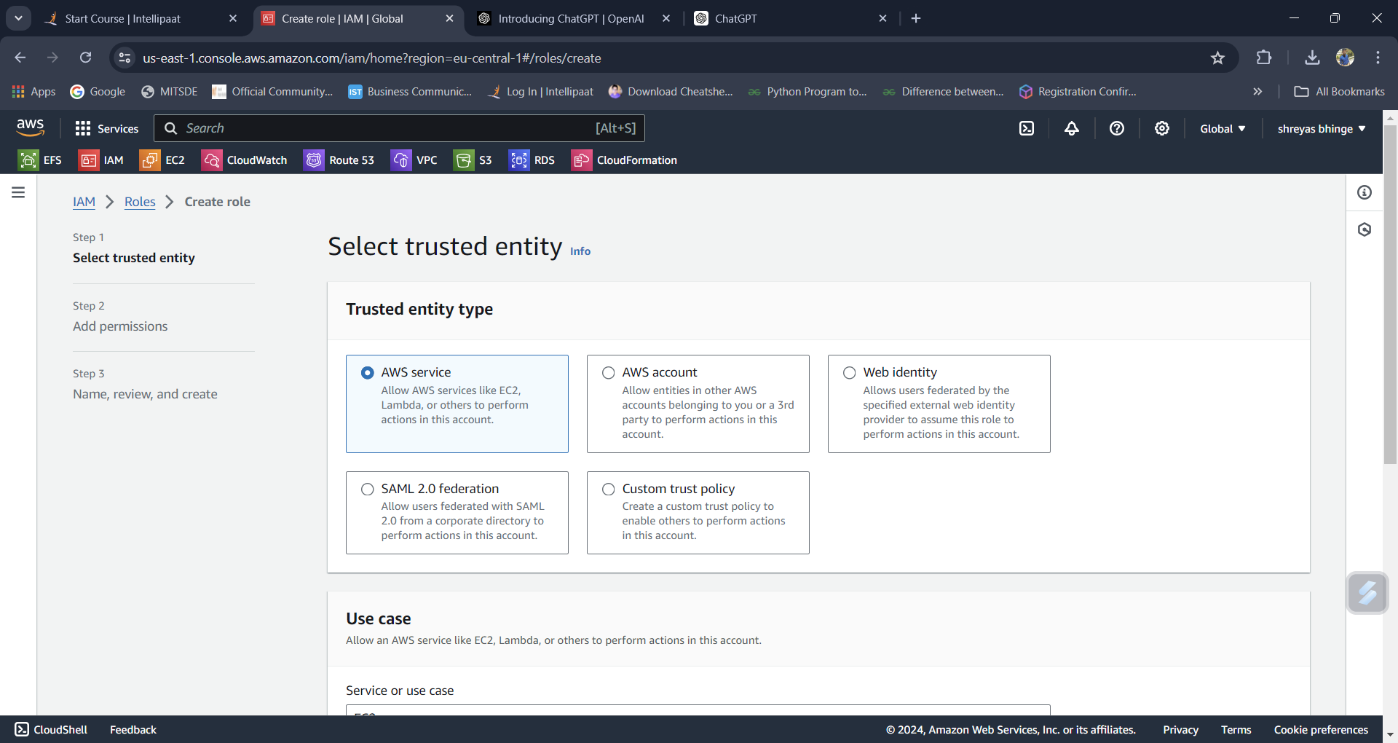

Step 2: Attach Policies to the Role

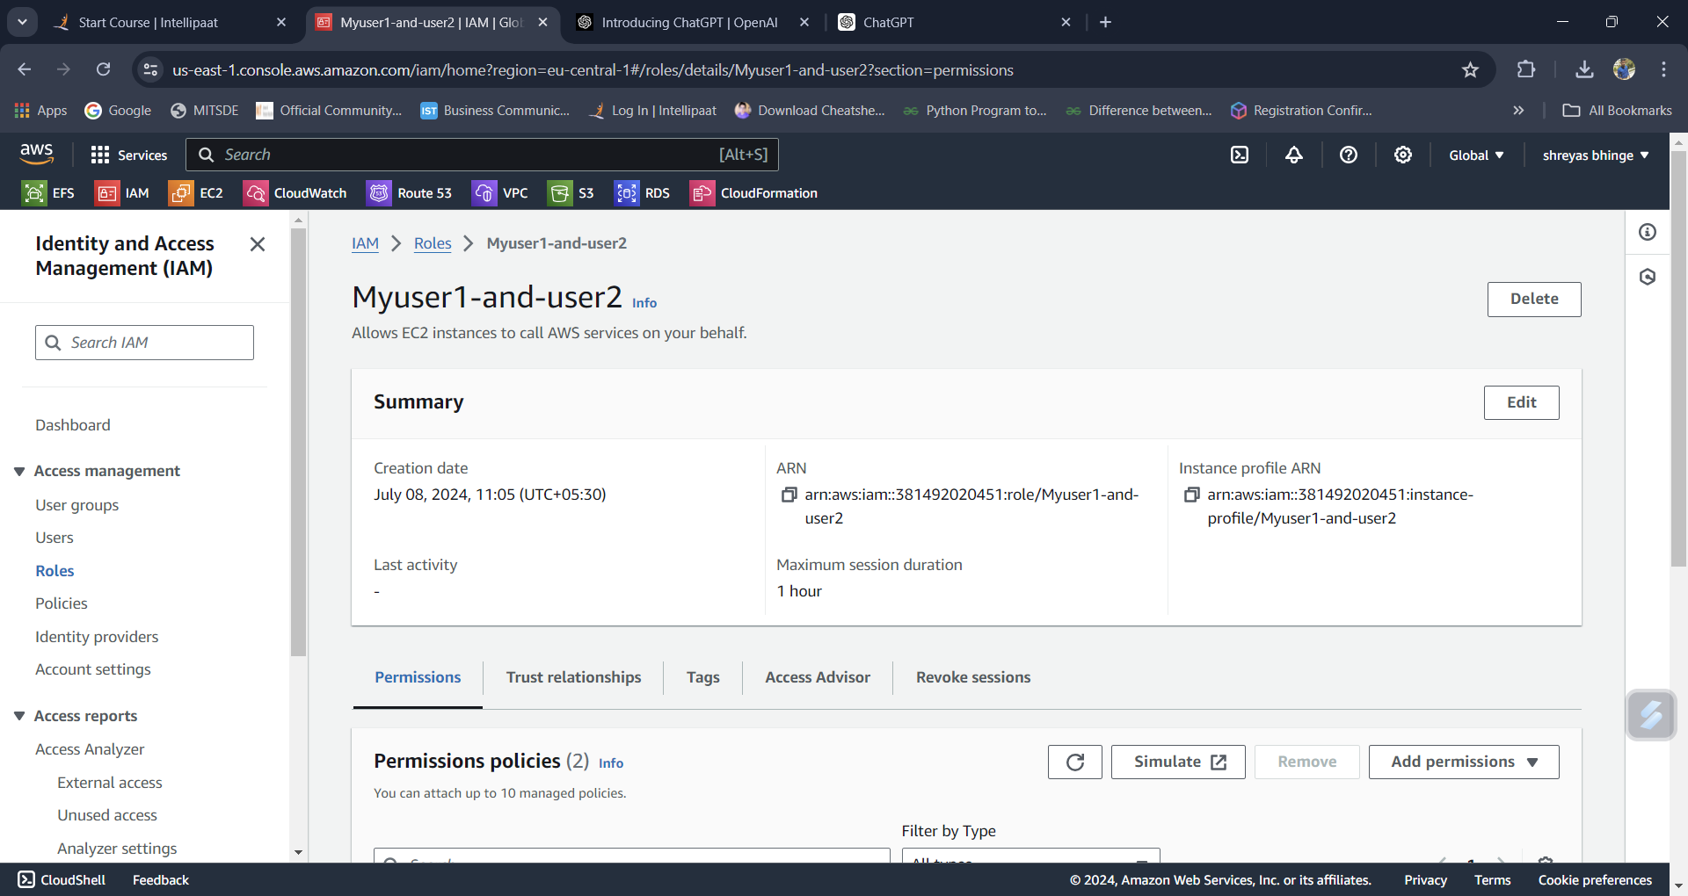

Step 3: Modify the Trust Relationship

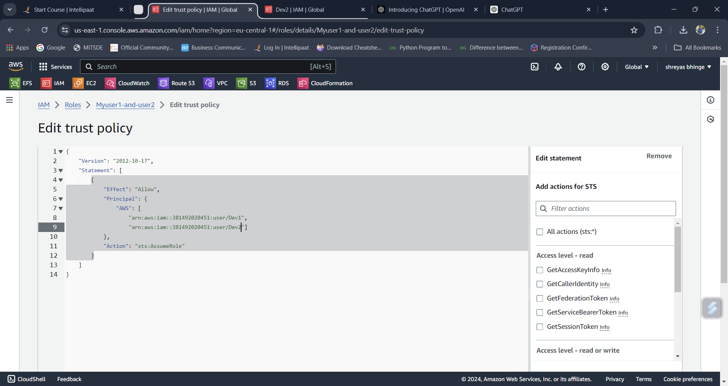

Step 4: Assign Role to Users

1. Assign Role for Dev1 as Myroleforuser1

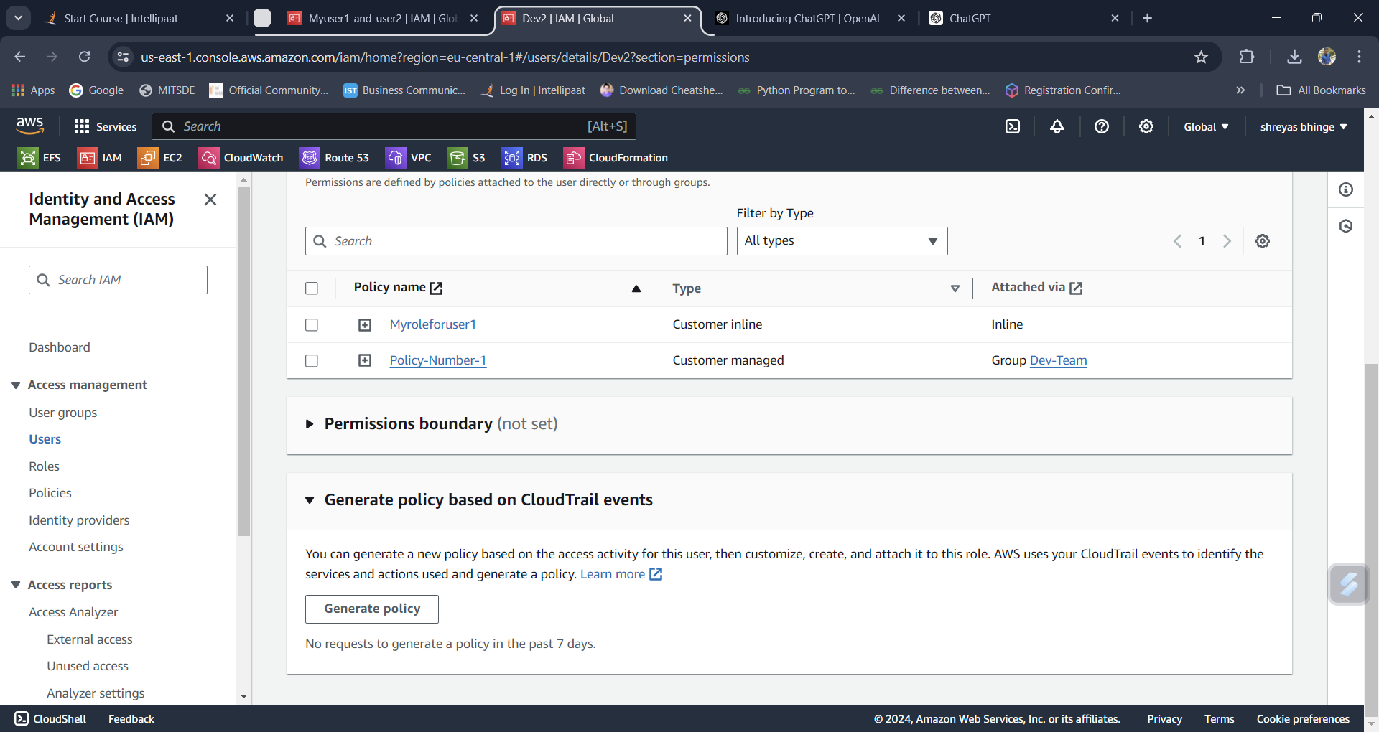

1. Assign Role for Dev2 as Mydev1role

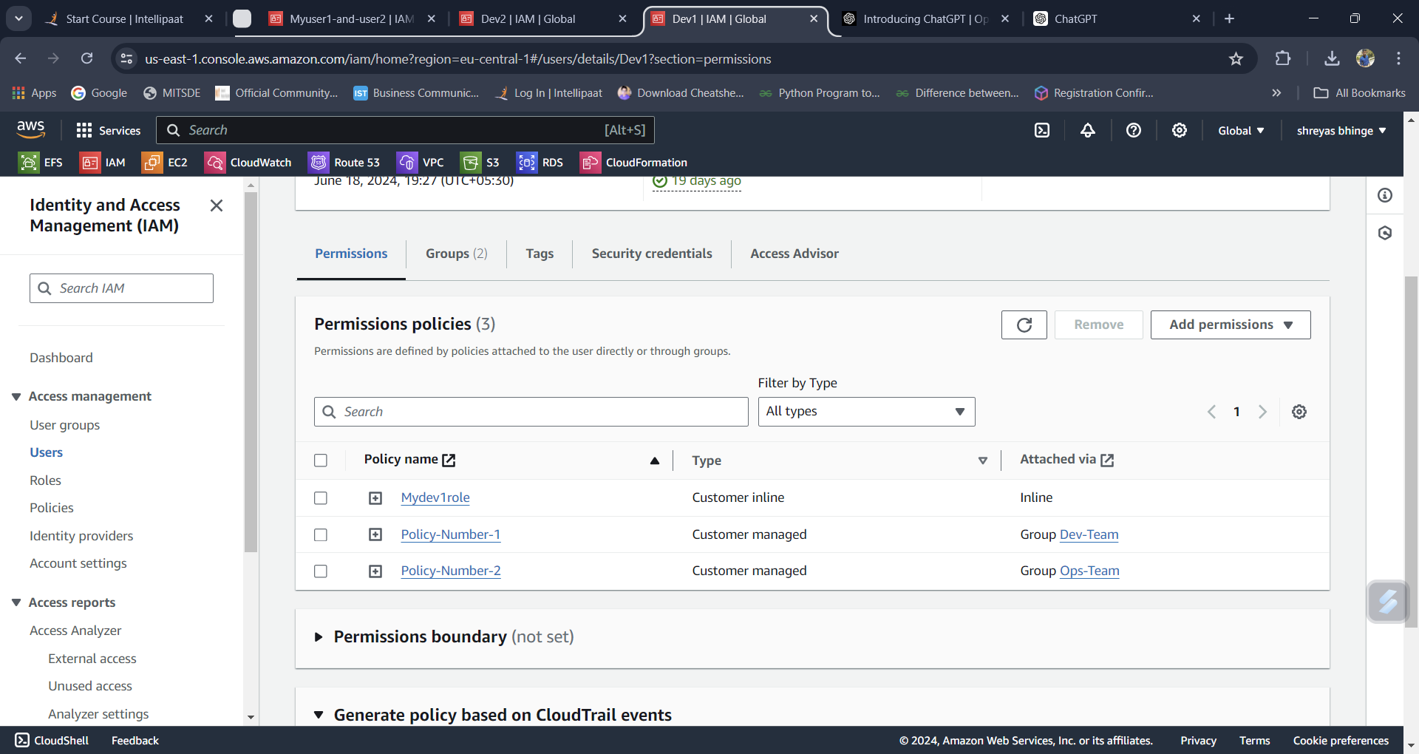

Step 5. Switched the role to Myuser1-and-user2

